August 15, 2020

Dear Editors,

We would like to thank you for considering our manuscript and for its review by you and your reviewers. We appreciate the comments and have included changes to almost every request made by the reviewers. These changes have helped to clarify and complete the manuscript, so thank you. The positive comments by were appreciated, and we are happy that you believe our contribution shows that the moisture impact on twisted polymer actuators is a matter of importance.

In the document below, we have attempted to break down each reviewer comment. We provide the original comment, along with a specific response, and in most cases, the original and updated manuscript text or figure. Please, note that for those comments where major changes have been implemented, we direct the reader to the updated section in the manuscript. We hope that this helps to ease the follow-up review of our revisions. Once again, thank you. We look forward to your final decision regarding our manuscript.

# Sincerely,

Diego R. Higueras-Ruiz

Ph.D. Student

Northern Arizona University

Department of Mechanical Engineering

College of Engineering, Informatics, and Applied Sciences

# **Reviewer 1**

1. Comments:

“The evaluation of STPA is insufficient. Although, the contractile strain, modulus are evaluated qualitatively, the evaluation of torque that STPA can generate is also required. The torque change according to not only the moisture absorption, but also the temperature change.”

## Response:

With the aim to more completely and explicitly report the moisture dependences of the thermal actuation response of twisted polymer actuators, we have conducted two more tests. In the first test, torsional thermal actuation under an isotonic torque is shown for three different pitch angles STPAs (36, 25, and 15°) at two percentages added moisture by weight (0 and 4%) (Figure 9 in the updated manuscript). For the second test, we study the linear thermal actuation of TCPAs under an isotonic tensile load at the above moisture percentages (Figure 11 in the updated manuscript). The results show an increase in actuation for those samples at 4% moisture content of approximately 100% for STPAs at ~80°C and a 50% for TCPAs samples at 100°C. In these two tests, the contribution on actuation by hygroscopic actuation is assumed to be null, since both tests were conducted with a heating rate of 3.75°C/s, and the hygroscopic actuation requires of a much longer actuation time to obtain measurable hygroscopic actuation responses.

Figure 9 and 11 have been added in the updated manuscript and Figure 10 from the original manuscript has been removed. Figure 10 was used in the old manuscript to show the potential impact of moisture content on torsional thermal actuation for STPAs by using the kinematic model presented by Swartz et al. [1].

**Original figure:**

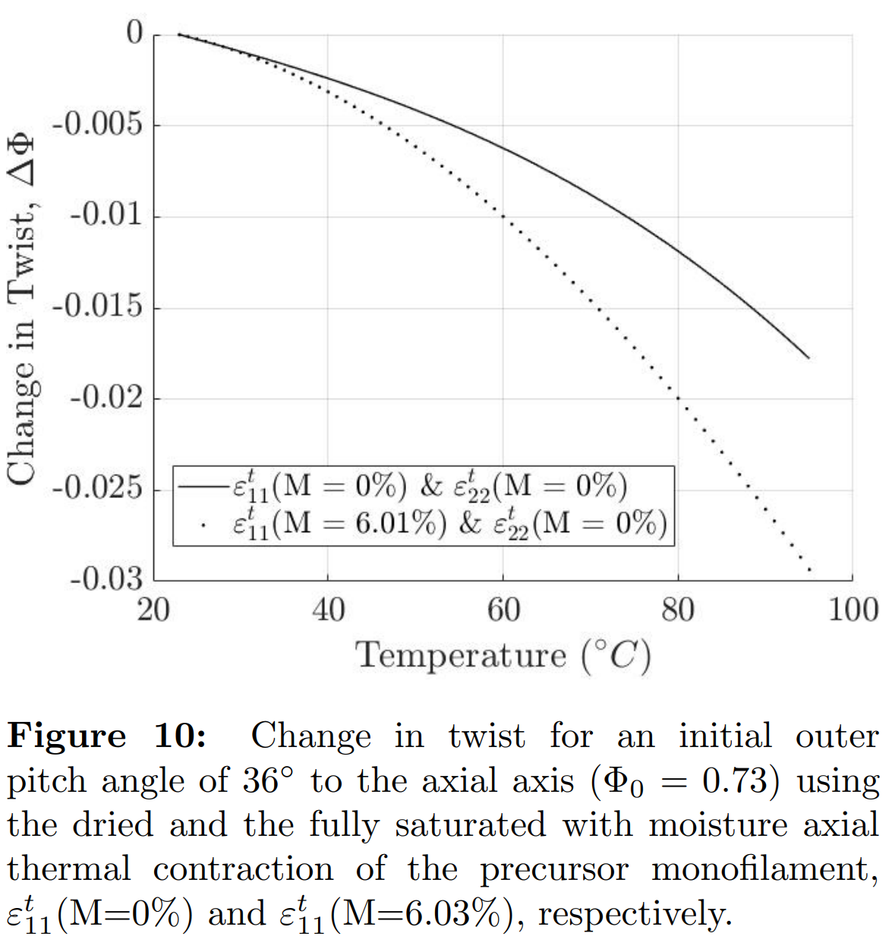

**Updated figures:**

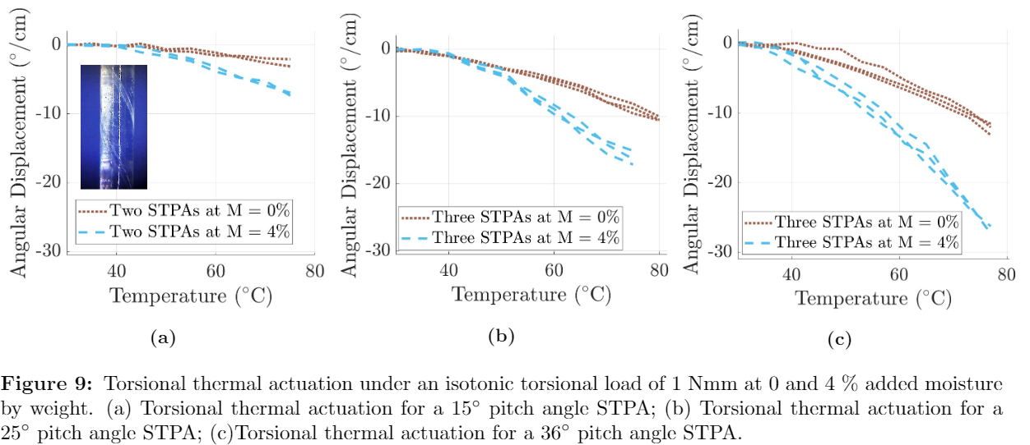

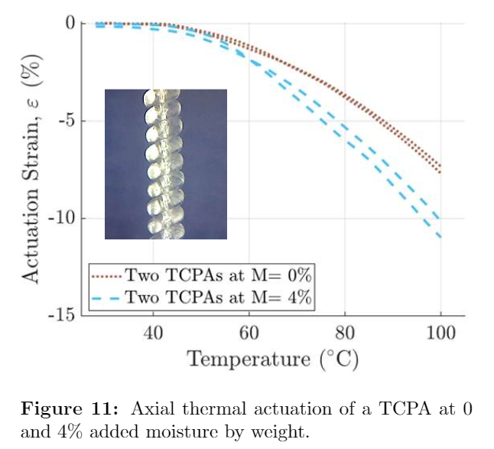

1. Comments:

## “In this paper, a STPA with a 36° pitch angle is used. However there is no explain about why 36° pitch angle is used. The evaluation of STPAs with various pitch angle is also necessary.”

## Response:

We added text to explained why a 36° pitch angle STPA was used in the updated manuscript (see updated text below). Additionally, we now present results for torsional thermal actuation under an isotonic torque for three different pitch angles STPAs (36, 25, and 15°) at two percentages added moisture by weight (0 and 4%) (Figure 9 in the updated manuscript, also presented in Comment 1).

**Updated text:**

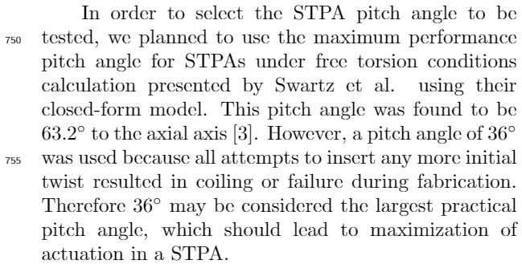

1. Comments:

## “In caption of Figure 1, the temperature of phase 3 might be "70℃ ".”

## Response:

This typo has been corrected.

**Updated figure:**

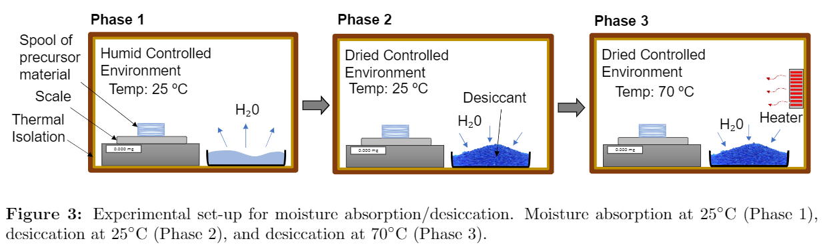

1. Comments:

“In second paragraph of chaper 3.2, the first word might be "In as much".”

## Response:

This expression has been removed from the text and does not appear on the updated text.

# **Reviewer 2**

1. Comment:

## “Figures 1 – 4 focus on describing the experimental set up. There is nothing wrong on the figures, however, I was wondering if authors could provide more scientific insights, such as the themo-dynamics, surface physics or mechanics models/ equations, alongside with the possible hypothesis on molecular structure/ phase changes?” Response:

We believe that section 3, experimental methods, is not necessarily the best place for mechanics models and additional information on the molecular structure. We believe that the goal of this section is to provide a reliable methodology and all the required information to allow the reader to perfectly replicate such experiments and obtain the same results as presented in this work. However, we did add quite a bit of information on the mechanics of the hygroscopic actuation to section 2, mechanics of actuation. Nonetheless, section 3 has been revised and updated with new text that provides more scientific insights, such as thermal analysis to calculate the proper heating rate for tests where heat transfer was involved, calculation of the mechanical strain induced by the hanging mass and aerodynamic forces applied for the hot air of the heat gun in the experimental set-up for the axial thermal contraction, and other matters that guaranty the reliability of the results in this work.

1. Comment:

## “The moisture driving actuation of polymer structure has been quantified, but the analytical interpretation is very limited, a significant gap left toward the understanding of this phenomenon, i.e. how’s relationship between the moisture percentage to the actuation? Any analytical views on controlling of actuation with different geometrical variations?” Response:

In order to better explain, both, thermal and hygroscopic actuation on twisted polymer actuators, we have added a new section (Section 2, Mechanics of Actuation) at the beginning of our manuscript. This section is divided by three subsections: micro-structure of the precursor monofilament, principle of hygroscopic actuation and moisture absorption, and principle of thermal actuation. This section starts by explaining the micro-structure of drawn nylon and how the anisotropic properties of the monofilament are related to the micro-structure. Then, we used this anisotropic behavior and the different dimensional growth methods (moisture-induced swelling and thermal expansion) to explain the mechanism of actuation for both, hygroscopic and thermal actuation.

However, the goal of this work is not to develop a model that predicts actuation based on moisture content or to develop tools to control moisture/actuation in TPAs. Rather, we believe that the major points of our paper are to inform the scientific community (1) that thermal actuation on TPAs is strongly dependent on moisture content and this matter needs to be taking into account in future modeling and (2) that TPAs are capable of generating hygroscopic actuation. The reviewer’s points about relating moisture percentage to actuation and controlling actuation that may be the subject of future work.

1. Comment:

## “The actuation mechanism has been poorly explained, a hypothesis is far from enough. I would consider a mechanics simulation as satisfactory but can live with some simple scaling at this stage.” Response:

## We added a new section (2.3) that addresses the mechanisms of hygroscopic actuation. The hygroscopic actuation is based on the moisture absorption behavior of some polymers as well as moisture-induced swelling of nylon, both of which have been previously modeled and validated by other researchers. In addition, in Section 5, we propose insights for modeling the hygroscopic actuation of TPAs at room temperature and how the modeling of moisture dependencies of mechanical and thermal properties can be approached. These insights are based on variation of the mechanical properties as a function of moisture content which has been modeled by using moisture-time superposition principle.

## See the updated text below.

**Updated text:**

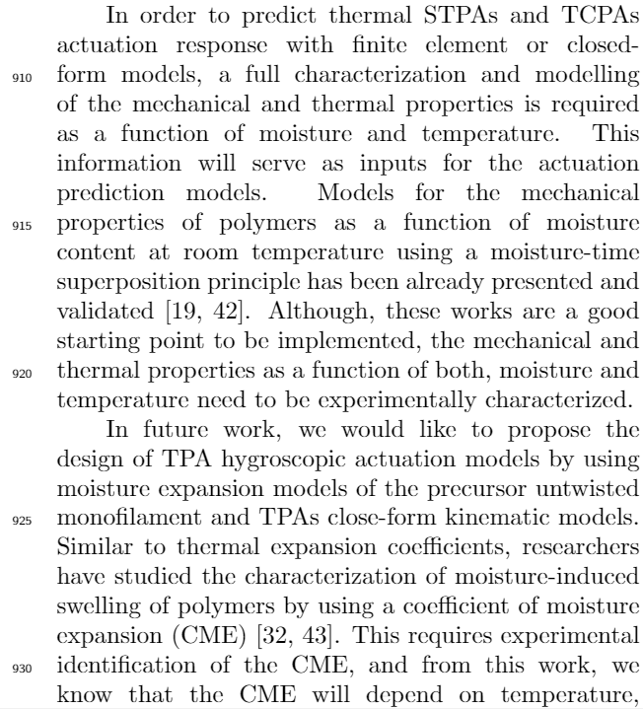

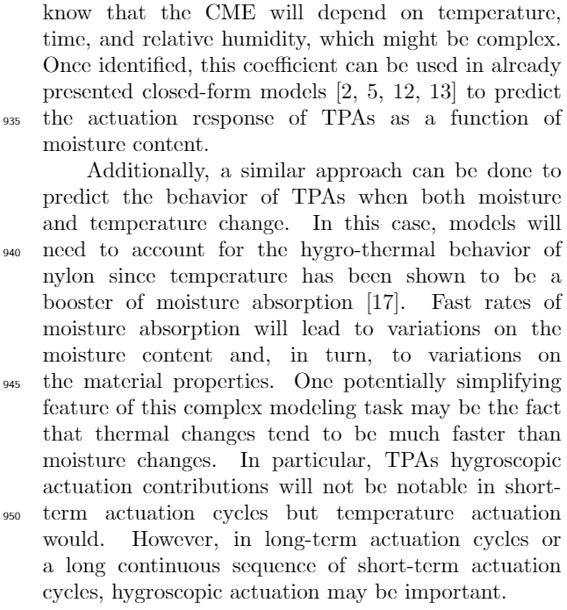

1. Comment:

## “The writing format in this manuscript general looks more like an engineering report. I would recommend authors to revise accordingly to a higher standard with an improved scientific interpretation.” Response:

We have changed the structure of our manuscript.

**Updated structure:**

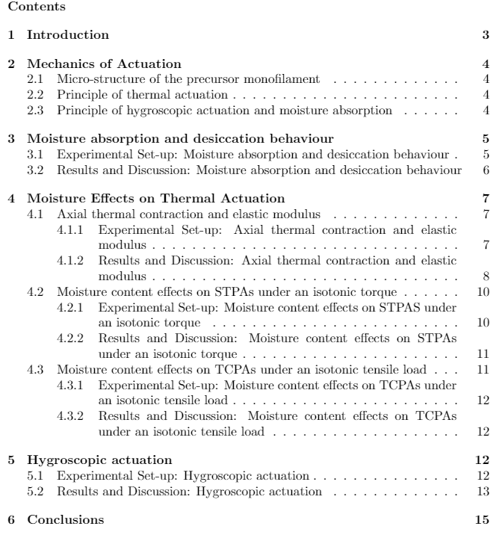

# **Reviewer 3**

1. Comment:

## “The title is a little misleading. A title recommendation would be “Moisture’s significant impact on Straight Twisted Polymer Actuation,” so the readers are not expecting results on the TCPA.”

## Response:

We definitely see how the title could mislead readers. However, since we are very convinced that moisture can have a great impact on STPAs and TCPAs, we have put an effort in running a new set of tests that also show the actuation response of a TCPA as a function of moisture absorption (hygroscopic actuation) and the effects of moisture content on the thermal actuation of TCPAs.

Please, see Figure 11 in Comment 1 and Figure 14(b) below (also presented in the updated manuscript). We think that the addition of these tests makes the title “Moisture's significant impact on Twisted Polymer Actuation” appropriate.

**Updated figure:**

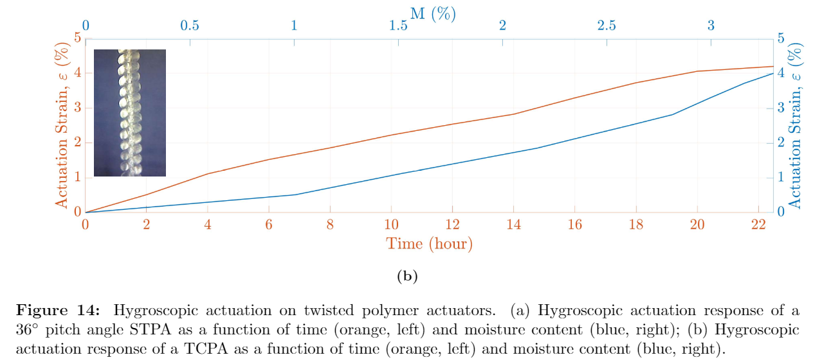

1. Comment:

## “Abstract, paragraph 1:”

## Response:

The abstract has been changed to one paragraph.

1. Comment:

## “2.2. Free torsion hygroscopic actuation experimental set-up: State what the fiber material is and the dimension.”  Response:

We have stated the material and dimension that have been used through this entire work in a new section that is called “Mechanics of Actuation”. See the updated text bellow.

**Updated text:**

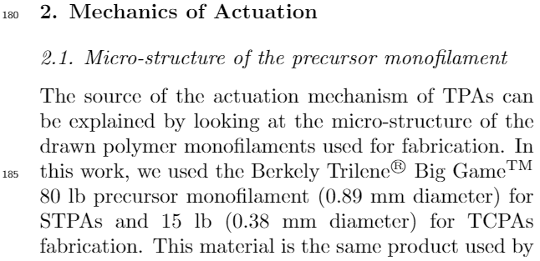

1. Comment:

## “Figure 2: Collet is spelled wrong, says “Collect.”.” Response:

This typo has been corrected.

1. Comment:

## “Axial thermal contraction. Does the 9g mass have any effects on the axial thermal expansion results? The axial modulus is a function of temperature and may cause displacement errors.”  Response:

To analyze the effect of the 9 g mass on the axial thermal contraction results, we assume that the material is linear elastic and then use stress from the 9 g mass to find strain in the material. In this analysis, we use the characterization of the axial modulus as a function of temperature for a desiccated monofilament presented in [2]. In this work, the axial modulus of the same monofilament used in our work was characterized with the equation

, (1)

where T is the temperature in °C and is given in GPa. Using this equation, we obtain an elastic axial modulus of 0.65 GPa at 85°C. The applied tensile stress induced by the 9 g hanging mass was approximately 0.12 MPa. Using the equation, , at a temperature of 85°C, the axial strain is approximately 0.0185%. The thermal strain, , at a temperature of 85°C, is equal to 0.18%. This implies that the error conducted by the hanging mass is equal to a ~10% error.

We found this error to be much greater than we initially expected, thus this test was rerun with a hanging mass much lighter (approximately 1 g) to avoid any induced mechanical stress in the material testing. Figure 6 in the manuscript (which is an update of Figure 8 in the original paper) presents the results for axial thermal contraction and axial modulus with the 1 g mass.

**Original figure:**

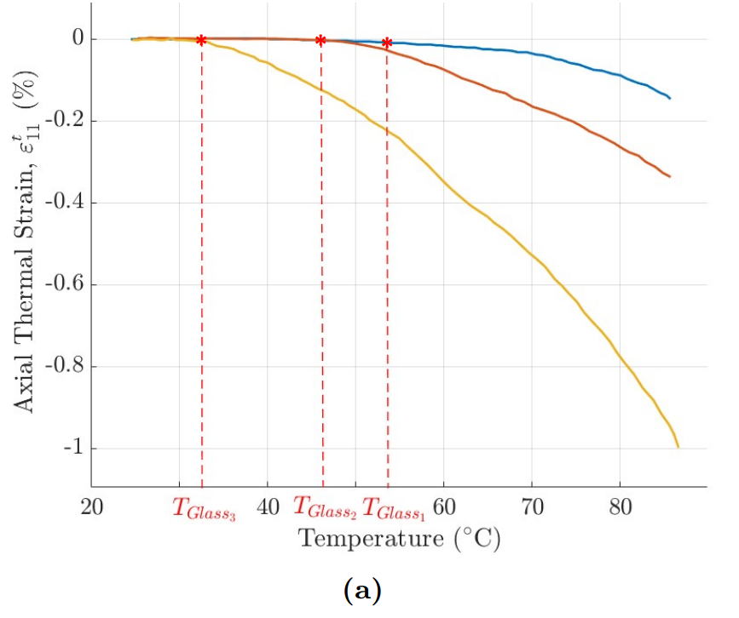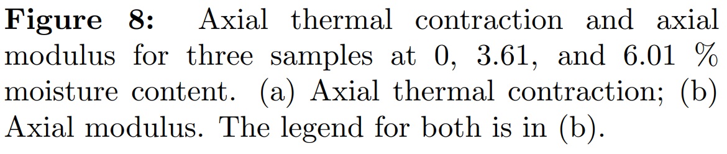

**Updated figure:**

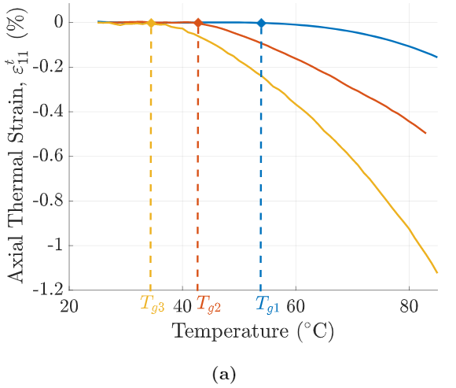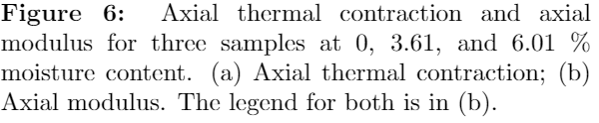

1. Comment:

## “Moisture content effects on axial thermal contraction, ϵ_11^T, and axial elastic modulus, E_1. grammar error: “…the latter shows and increase in axial thermal contraction six times…” change and to an.” Response:

This typo has been corrected.

**References**

[1] Swartz, A. M., Higueras Ruiz, D. R., Shafer, M., Feigen-baum, H., and Browder, C. C., 2018. “Experimental characterization and model predictions for twisted poly-mer actuators in free torsion”. Smart Materials and Structures, 27(11)

[2] Higueras Ruiz, D. R., 2018. “Characterizing material properties of drawn monofilament for twisted polymer actuation”.